Multicultural Community
Voice in Action:
A how-to method in
civic engagement and civic participation
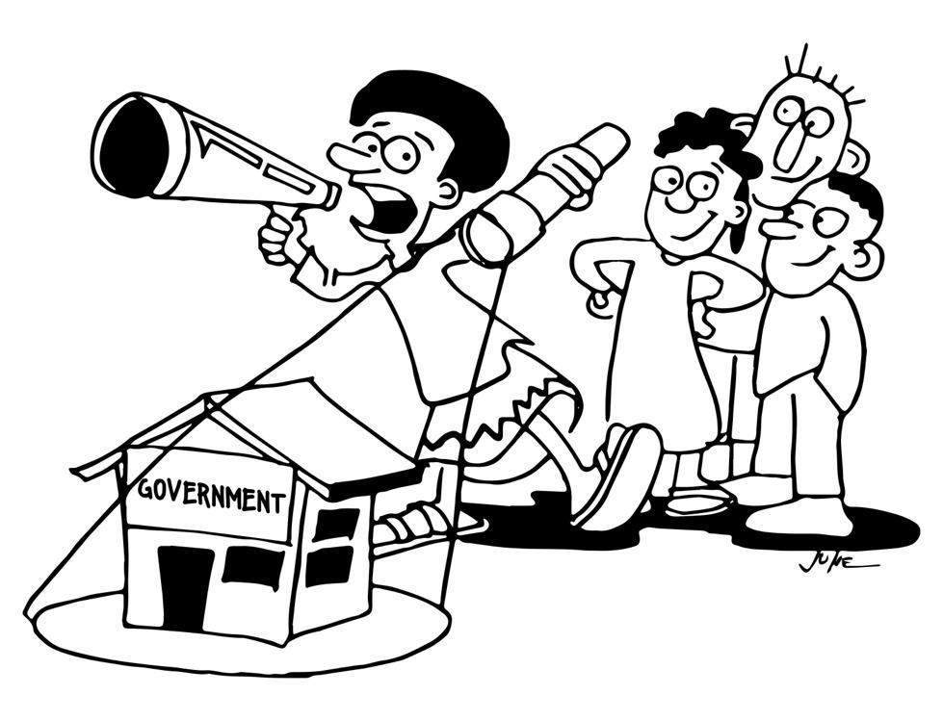

Table of contents

Contents | 2
Acknowledgments Page | 3
Introduction | 4
What are the three phases of Multicultural Community Voice in Action? | 5
Phase 1: Enabling Victorian Community Member User Engagement | 6
Understanding public policy Governance and politics | 6
1.2 Prepare local materials and resources | 7
1.3 Citizen/service user education and mobilisation | 7
1.4 Build networks and collations | 7
1.5 Establish relationships and connections | 7
Phase 2: Engagement via Community Gathering | 8
2.1 The initial meeting (meeting 1) | 9
2.2 Comparing and assessing standards meeting (meeting 2) | 9
2.3 The working group/committee score card meeting (meeting 3) | 9
2.4 Voting | 11
2.5 Interface meeting | 12
Closing and celebration | 13
Phase 3 Improving Services and Influencing Policy | 14
Implementing the civic engagement and civic participation action plan | 15
Monitoring and support | 15
Building networks and coalitions | 15
Advocate and influence | 16
Additional tips | 16
Appendix 1: Victorian State Budget Process | 17
Appendix 2: Stakeholder analysis – who do you want to collaborate with | 18
Appendix 3: Comparing and assessing template | 19

Acknowledgement

This document, which was developed in 2020, has been adapted from World Bank and World Vision documents to reflect Victoria’s civic engagement and civic participation context.
Introduction
Multicultural Community Voice in Action is a place based local advocacy method that transforms the dialogue between multicultural communities and government to improve services like yours e.g. health care, education, financial literacy, leadership, which impact the daily lives of multicultural communities.

The goal of Multicultural Community Voice in Action (MVA) is to improve the accessibility and quality of public services for multicultural communities in Victoria. Through collaborative, non-confrontational dialogue between service users, government and providers, users are empowered to monitor and seek accountability for service delivery and to take collective responsibility for services. MVA is based on the view that each Victorian community member has the right to hold to account the government for fulfilling its commitments.
Through MVA government is held accountable for service delivery against its own standards. These are existing standards which are documented by government departments and are publicly available. Standards vary from department to department and across the three tiers of government and might include, for example, classroom size, staffing levels at a clinic or aged care facility. Existing government standards are a crucial part of MVA and provide the key distinction between traditional advocacy and advocacy using MVA.
MVA also gives your service users the opportunity to voice their opinions about what makes your service good (or not) from a multicultural and equity perspective. Through this process, your service users generate indicators that describe what makes a good service good. Once they have generated these indicators, they rate the performance of services against them. This is valuable data that you can use to improve your service and for your advocacy efforts with the government.

What are the three phases of Multicultural Community Voice in Action?

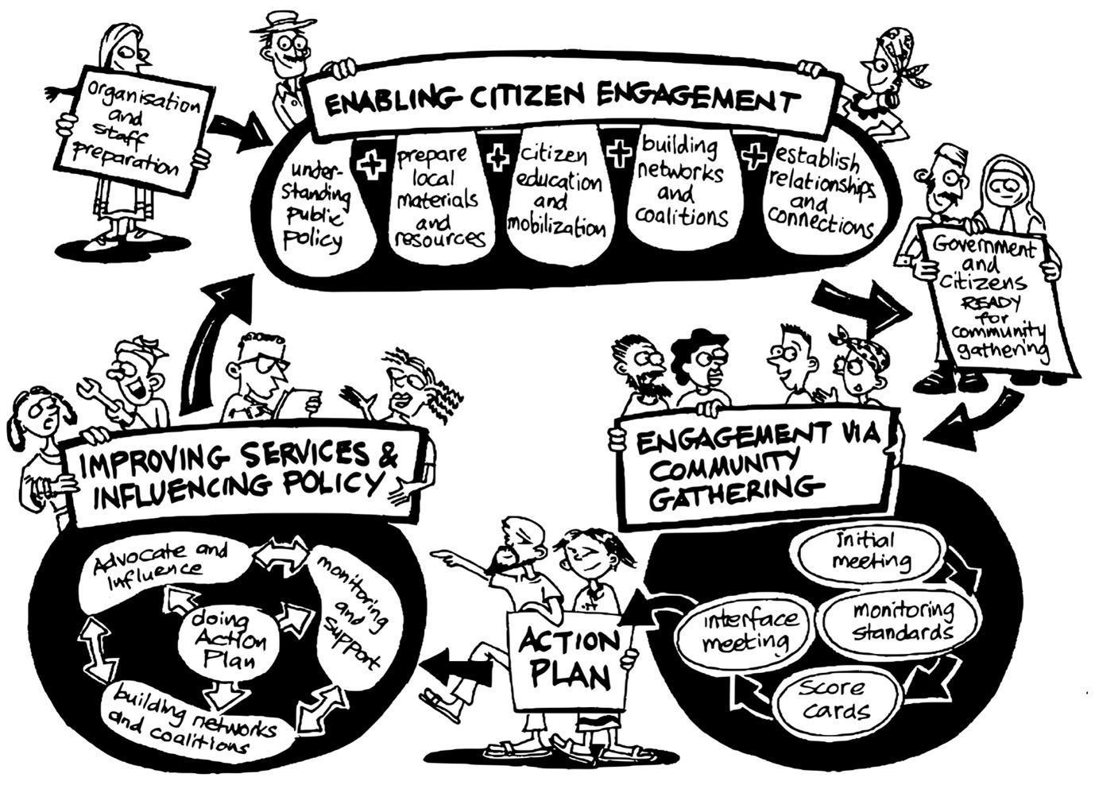

MVA’s three phases:
- Enabling Citizen Engagement
- Engagement via Community Gathering
- Improving Services & Influencing Policy

Phase 1: Enabling Victorian Community Member user Engagement
This phase is your organisation's community engagement/meeting planning phase. The objective of this phase is to prepare you and your working group/committee to engage productively and positively in meetings with the government. There are five sub-activities within this phase, shown below and can be undertaken in any order.

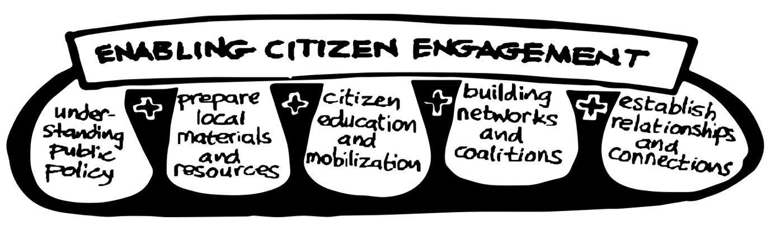

- Understanding public policy
Governance and politics
Access government documents to produce a clear, simple summary of the structure of government politics, standards and commitments, decision making processes and budget timelines from the Federal to Local levels.
- Map the type and frequency of political commitments across political parties to your services and programs.
- Understand and briefly document government processes and systems in relation to policy development and budgeting environment for the service you are delivering. Look for specific names about who makes the policy decisions and who influences them.
- Map official and unofficial forums for citizen/service user engagement that relate to your service

Analyse the socio-historic and political context of services that are similar to the one(s) you are delivering.
- Gather information about settlement histories of the communities-recently arrived versus not, for example.
- Identify minority groups within and between communities e.g. women, older members of your community, sexually diverse people (LGBTQI+) community members, ethnic minority groups, disable people.

  - Prepare local materials and resources
When staff at your organisation have summarised available documents, adapt the information into simple, accessible, visual and appealing materials in the local languages, for example, for a community level media campaign and for your working group/committee members.
TIP: Don't forget the government standards - these are vital

  - Citizen/service user education and mobilisation
Using the local materials you have prepared in step 1, work with local partners such community radio and faith groups to mobilise and sensitise community leaders and groups about your upcoming MVA campaign and what you have learnt about the government policies as they relate to your service. This activity aims to make the broader community aware of the work you are leading with your working group/committee. This activity is strategic step because you are telling the whole community (including those who do not use your services) that you are planning to work with the government to help deliver services to their community. Don’t for get these community members are the voting public.

TIP: emphasise, citizenship - both rights and responsibilities - and government standards

1.4 Build networks and coalitions
Conduct a stakeholder analysis to identify who to collaborate with and who you want to be on your working group/committee.
TIP: Establish the MVA working group/committee- The members of the working groups should organize and facilitate the meetings in Phase 2. The working group could consist of members you’ve identified in steps 1.3 and 1.5 and people from diverse backgrounds who use your service.

1.5 Establish relationships and connections
For MVA to succeed, your organisation must facilitate a warm, collaborative relationship with the government and your service users. Open communication and trust is vital, because some of your partner organisations/stakeholders - especially nurses, teachers and government officials - may feel that they are being criticized at the upcoming MAV campaign. Building relationships is crucial to ensuring participation and political will.

TIP: Before holding the community gathering session, staff at your organisation should:
- Decide the venue- consider cultural safety.
- Agree on which user and service provider groups to invite. The working group should decide the focus groups that will participate in the various sessions.
- Decide the date and times
- Provide invitations
- Organize and train the facilitation team
- Obtain materials. MVA requires a large number of flip charts.

Phase 2: Engagement via community gathering

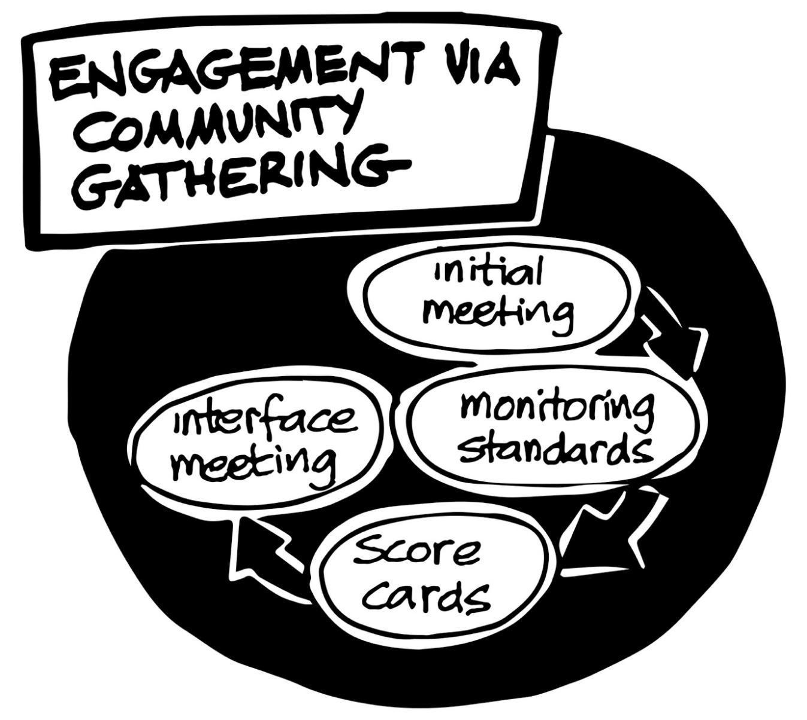
This phase is the heart and soul of the Multicultural Community Voice in Action method. It includes a series of meetings involving large and small focus groups (with the members of your community/ your working group/committee that you mobilised in step 1.3 of phase 1) that assess the quality of your service and identify ways to improve their delivery. During this phase, representatives of your service users, government and other key stakeholders provide information about the performance of your services and make proposals to improve it. It is vital that your organisation participates.

2.1 The initial meeting (meeting 1)
This meeting is designed to launch the monitoring activities of Multicultural Community Voice in Action campaign and introduce your working group/committee and government representatives to all the processes and expected outcomes of the meetings you planned in Phase 1.

2.2 Comparing and assessing standards meeting
(meeting 2)
This meeting is designed to allow your working group/committee members and government to compare government standards with the actual conditions in your service(s).

Members of your committee/working group meet with government representatives and/or funders to discuss government standards, visit your organisation, meet with your service users and compare government standards with reality.

TIP: During their visit with government representatives and/or funders have a flipchart prepared to discuss the government standards compared to your services.

  - The working group/committee score card meeting (meeting 3)
The objective of the Community Scorecard meeting is to get the opinions of your working group/committee members about the performance of your service. These are not government standards. Rather, they are the ideas and opinions of your working group/committee members themselves.
TIP: At the meeting: Form focus groups. Divide the working group/committee members into age and sex / gender disaggregated small focus groups, to ensure maximum participation. You should also form focus groups for marginalized or vulnerable groups such as pregnant women, people with disabilities, older people, etc. Go through the scorecard process for each group.

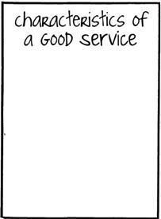
Define performance measures. Ask focus group participants to think about the characteristics of an ideal service. 'How would you describe a good service delivery model? Some prompting may be needed. For example, "Would you expect staff to respect you?", “What sort of cultural things should we consider in our service?” or “Which minority group’s voice needs to be included?”.

TIP: Record these performance measures, or "indicators" on a sheet like the flip chart at right and label it “characteristics of a good service”.

Introduce the smiley scale. Next, introduce a simple voting method. The “smiley scale” either using an app or butcher's paper. For each indicator, each focus group working group/committee members will vote, by indicating whether he/ she/they/them feels "very good", "good", "OK", "bad", or "very bad" about that particular indicator.

Note: Depending on the facilitator's discretion, do a practice run on something other than your service i.e. football team's performance (see pictured below). This is to test if the working group/committee members understand the voting procedure. Request ideas for a symbol or simple drawing that will represent the performance measure for illiterate working group/committee members. Below, the test example of a local football team's performance is represented by the image of a football. Nice aged care service staff might be represented by a smiling face with a nurses' cap.
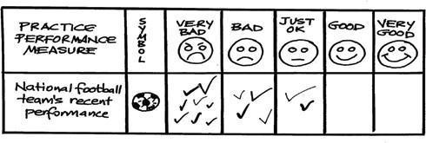

2.4 Voting
Next, transfer the criteria from the "Characteristics of a good service" flip chart to the group's scorecard and invite them to vote.

Tip: Create the scorecard by sticking together the three (characteristics of a good service; smiley scale and voting) flipcharts in a horizontal line across a wall in the order displayed just below.

Once everyone has voted, examine the votes and ask your working group/committee members to record a tally of scores - represented by a smiley face not a number - in the smiley face columns.

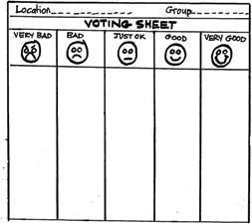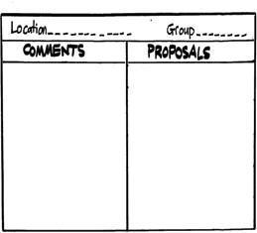
Tip: Deciding on an average score might require a lot of discussion, especially if there is disagreement among the group members.

Next, ask service users to comment on the reasons they voted the way they did. Record these reasons under the column marked "comments". For each performance measure, encourage communities to propose solutions and record these. These proposals could include actions to be taken by you, government, or any other stakeholder.

Tip: Scorecard sessions should be facilitated by a minimum of three people, the lead facilitator, someone to record the information on the fiip chart and someone to record the information for documentation. Remember, the Score Card should be repeated for each focus group. This way, we ensure that we get the opinions of marginalized groups.

2.5 Interface meeting
Once the " Comparing and assessing standards " and "Community Scorecard" meetings are complete, you are ready to convene an "Interface Meeting".

The objective of the interface meeting is to encourage dialogue among working group members/committee, your organisation’s staff, government, and other stakeholders about the quality of your service.

Together, participants decide how they will improve services so they respond to multicultural needs using an equity lens. Based on this information, an action plan is prepared which includes the allocation of responsibilities and timelines to enable the work to be taken forward.

The Interface Meeting is the most critical session of the Community Engagement process as this is when action will be decided.

TIP: The Interface Meeting can take several hours - plan to serve lunch during the meeting. During the meeting, working group/committee present the results of the Comparing and assessing standards session and the Community Scorecard sessions. Participants review the proposals that have emerged from the process thus far.

Next, ask the meeting attendees to prioritize some objectives to be included in a collective action plan.

The objectives should be Specific, Measurable, Achievable, Realistic, and Timely (SMART). Record these objectives on a flip chart like the one below and ensure that those involved are truly committed to its implementation.
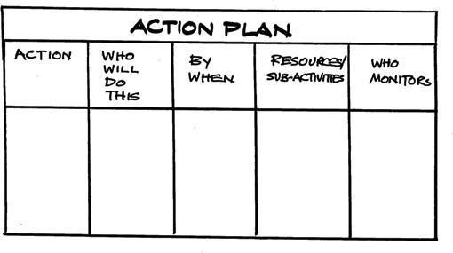

Tip: Sometimes, these objectives will require the formation of a working group to effectively implement.

Note the difference between an action and an issue. For example, noting down 'more tutors for a homework club' on an action plan is noting the problem or issue not the solution.

If ‘more tutors for a homework club’ is raised, as participants, what do we want the government to do about the tutors? So an action for example would be: write a letter to the Minister for Education; submit a proposal for increased tutor numbers who are trained to meet the needs of multicultural youth.

Encourage meeting participants to come up with smaller, practical activities that are achievable to start off with - don't encourage unrealistic or ambitious actions to start. You want incremental activities that can be achieved and demonstrate the possibility of change.

Closing And Celebration

Besides the Action Plan, the Interface Meeting is important as it provides participants with the opportunity to share the results of the work carried out together. The facilitator should emphasise that the Action Plan belongs to both the working group/committee, the border community and government and it is their responsibility to make sure that the proposed changes are carried out.

Tip: At this meeting, schedule a follow up meeting to monitor progress and at the end of the meeting, an opportunity should be provided to the participants to evaluate the Community Gathering, its weaknesses and strengths. Request from the group any thoughts on what they liked or didn't like about the Community Gathering process. The meeting could end with a celebration of food, song and dance.

Phase 3: Engaging government, improving services and influencing policy
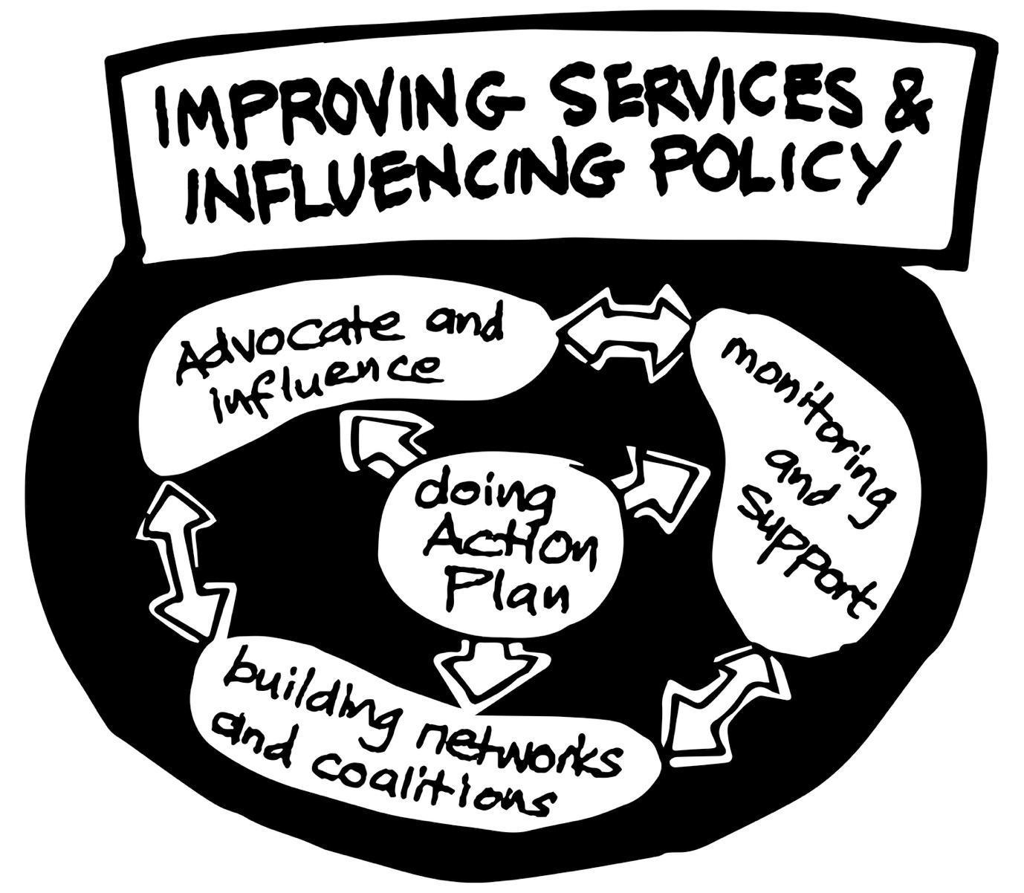
Congratulations! You now have a civic engagement and civic participation action plan. The objectives in this plan will guide your organization's strategic planning and government, tol ultimately improve lives. But in order to succeed, your working group/committee and staff will have to closely monitor the plan's implementation.
In this third phase, working group/committee, government, and you implement the action plan. But in order to be successful all of you must commit to undertake four broad activities:

Implementing the action plan:

Your staff should review the action plan after the Interface meeting. Carrying out the Action Plan is led by your staff, the working group/committee and other relevant stakeholders - those who volunteered or committed themselves during the Community Gathering. But no matter how "SMART" the objectives are, the individuals are responsible for their achievement. It may be helpful to divide the objectives into sub-tasks and seek the assistance of the working group/committee to complete these tasks.

Monitoring and support

Many times, individuals will commit to certain actions in a meeting, but will need substantial monitoring and support in order to ensure that they actually fulfil their new commitments. For this reason, the "Action Plan" includes a column titled "Who will monitor". The individuals named here should take their responsibility very seriously. The individuals named here should generally be your service users, your committee members and staff.

One suggestion might be to hang the action plan in public at your service or another public location such as your website, social media page, a community centre or local government office. This will ensure transparency and accountability of those responsible to carry out the actions. It will also encourage participation of the general community in the process to improve services.

Documenting actions taken is important to facilitate the monitoring of actions. Those responsible for carrying out actions, should be encouraged to keep records of action taken, progress made and to report back to the wider community on the progress via the media for example and to the relevant government representatives.

Building networks and coalitions
Often, the Action Plan will include some objectives that require the input or authority of a higher-level government official. In order to reach that official, your organisation will need to build networks and coalitions that will catch the attention of these higher level authorities. Work with peak bodies or local partners to create a successful advocacy coalition.

Advocate and influence
When an Action Plan includes ambitious objectives, you will need to be strategic about they way you seek to achieve your service delivery goals. Here are some simple guidelines for successful advocacy:

- Identify who can make the change your community wants. Be specific as possible. Don’t say “the Department of Education”. Who is the individual (identified by title and name) with the power?
- Who are your likely allies? How can you build a coalition or network that can press for the change you seek for your multicultural users?
- What is likely to persuade those with the power (don’t forget to emphasise cultural and equity needs)? Will they respond to political pressure? Pressure from the media? Pressure from a peak body or particular interest group?
- Are there existing civil society events or government processes that you may use in order to achieve your objective?

Additional tips
Keep good records!
Multicultural Community Voice in Action generates important information about the quality of your services and public services. This information should be kept as precisely as possible so that it can be used credibly to influence government.

Be sure to record the information generated during:
- Monitoring Standards session
- Scorecard sessions
- Interface Meeting (Action Plan)

Consider how your services might link with allies and coalitions.
Linking local level action to higher level action is often necessary to make sure action plans can be fulfilled. Efforts at the State level, for example, to meet with the Minister for Education, are often beyond the reach and capacity of your organisation and would require a broader advocacy objective.

Consider how to use the media
Journalists are often looking for stories. Organise committees and service users to speak to them about MVA activities but ensure that you have an outcome i.e. A success story to share including photos or video. Don't arrange to simply talk about the process of MVA. The media need a tangible outcome or there is no story.

Appendix 1
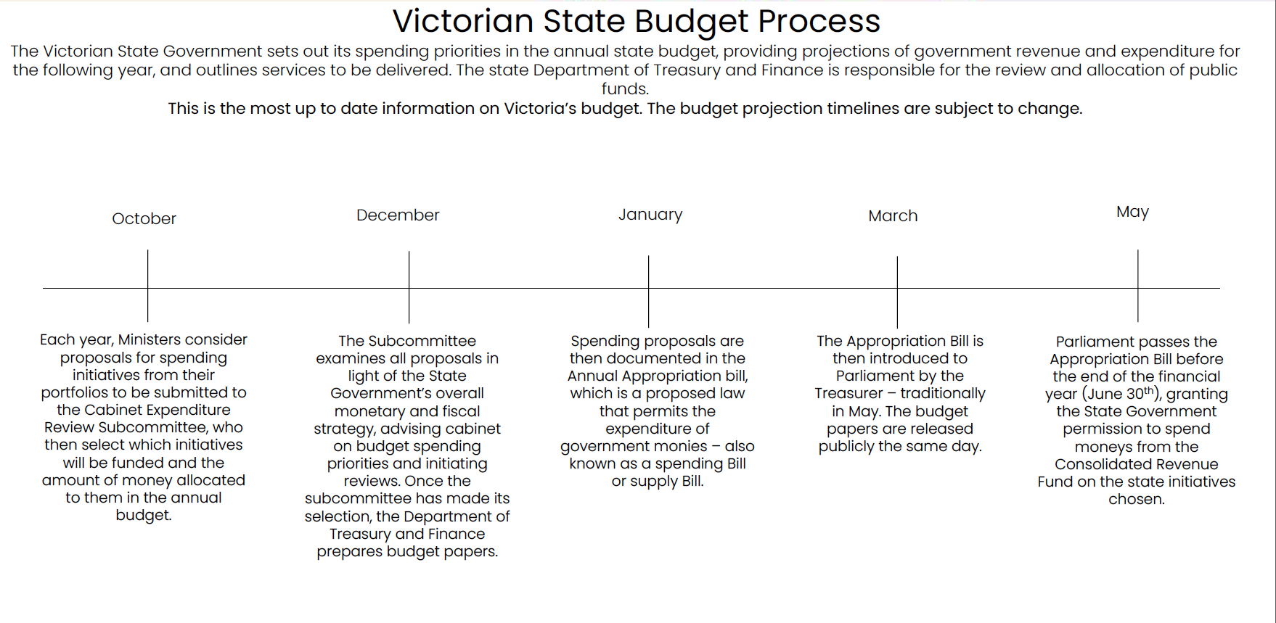
Source: Budget in Process in Victoria, Department of Treasure and Finance, Victoria State Government 2022.
Appendix 2- stakeholder analysis – who do you want to collaborate with?

Stakeholder grouping | Stakeholder details: (Name and position) | What approaches you will take to engage your key stakeholders

Appendix 3: Comparing and assessing template

The template allows you, your service users and government to compare government standards with the actual conditions of your service. The first row is an example.

Example: Homework club standards
Area: Dandenong homework club
Venue: Beautiful minds
Type of service input | Government standard | What’s happening in reality | Comment
Homework club for refugee and migrant children and families | Tutor/student rations of 1:1 or 1:2 | Tutor/student rations of 1:3 or 1:5 | Many of our students are newly arrived migrants with special needs the 1.3 ratio is not working for us

See appendix 1: Victorian State Budget Process.
See Appendix 2: Stakeholder analysis template
See Appendix 3: Monitoring and comparing standards template.

